Dr, Dhammika Alahapperuma

Secretary

Private Health Service Regulatory Council

No2A, CBM, 4th Floor,

Lake Drive Colombo -08

Asanga Wickremanayaka

Branch Operations Manager

Nawaloka Laboratories (Pvt) Ltd,

H. K. Dharmadasa Mawatha Colombo 02

***Ref -PHSRC/L/1132 – Letter***

Dear Dr, Dhammika Alahapperuma,

This is to refer to the letter PHRC/L/1132 dated 27/09/2022. This is to confirm that all the samples collected from the mentioned institute is been doing at the Nawaloka Laboratory Mathara, situated at No16, Ground Road, Uyanwattha, Mathara.

The said institute is registered at PHSRC under PHSRC/L/1284.

Thank you

You’re faithfully

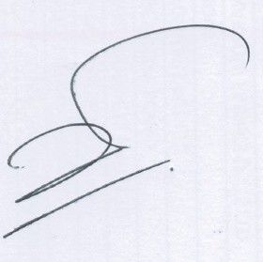

Asanga Wickremanayaka,

Branch Operations Manager

Dip (MLT) │ MSe(Health Admin) │ MBA(Health Care Management) │Reding for PhD

Nawaloka Laboratories (Pvt)Ltd

Colombo 02